Name : Parthib Kumar Das , Enrollment No: 12023052002018 , CSE , Roll No: 18

Institute of Engineering & Management, Kolkata

Email ID: PARTHIBKUMAR.DAS2023@iem.edu.in

Dasparthib111@gmail.com

Video Demonstration Link : https://www.loom.com/share/2214052a281d40c88c8ea59d2a89a349

Module Name : Automation with Selenium

Experiment Title : Web Element Identification
Problem Statement :
To identify and locate web elements on a webpage using Selenium WebDriver and different locator strategies such as ID, Name, Class Name, Tag Name, Link Text, CSS Selector, and XPath, and to understand how these elements can be accessed and interacted with during web automation testing.

Objective :

To learn how to identify web elements using Selenium locators such as ID, Name, Class Name, Tag Name, Link Text, CSS Selector, and XPath.

Tools, Software, and Concepts Used
- Python 3.x
- Selenium (latest version)
- Google Chrome / Mozilla Firefox
- WebDriver / Selenium WebDriver
- VS Code / PyCharm
- Required Python packages:
  - selenium
  - webdriver-manager
- Concepts: Web Elements, Locators, By class, CSS Selectors, XPath

Source Code / Implementation Steps
- Install the required packages using pip.
- Import Selenium and WebDriver-related modules.
- Open the required webpage using Chrome/Firefox.
- Identify web elements using different Selenium locators.
- Perform actions such as click, enter text, and select elements.
- Verify the identified elements and close the browser using driver.quit().
Source Code:
from selenium import webdriver
from selenium.webdriver.common.by import By
import time
driver = webdriver.Chrome()
driver.maximize_window()
driver.get("https://testautomationpractice.blogspot.com/")
time.sleep(2)
print("=" * 70)
print("INPUT ELEMENTS")
print("=" * 70)
inputs = driver.find_elements(By.TAG_NAME, "input")
for i, el in enumerate(inputs, start=1):
print(f"{i}. id='{el.get_attribute('id')}' | name='{el.get_attribute('name')}' "
f"| type='{el.get_attribute('type')}' | placeholder='{el.get_attribute('placeholder')}'")
print("\n" + "=" * 70)
print("TEXTAREA ELEMENTS")
print("=" * 70)
textareas = driver.find_elements(By.TAG_NAME, "textarea")
for i, el in enumerate(textareas, start=1):
print(f"{i}. id='{el.get_attribute('id')}' | name='{el.get_attribute('name')}' "
f"| class='{el.get_attribute('class')}'")
print("\n" + "=" * 70)
print("SELECT (dropdown) ELEMENTS")
print("=" * 70)
selects = driver.find_elements(By.TAG_NAME, "select")
for i, el in enumerate(selects, start=1):
print(f"{i}. id='{el.get_attribute('id')}' | name='{el.get_attribute('name')}'")
time.sleep(3)
driver.quit()
Output with clearly labelled screenshots:
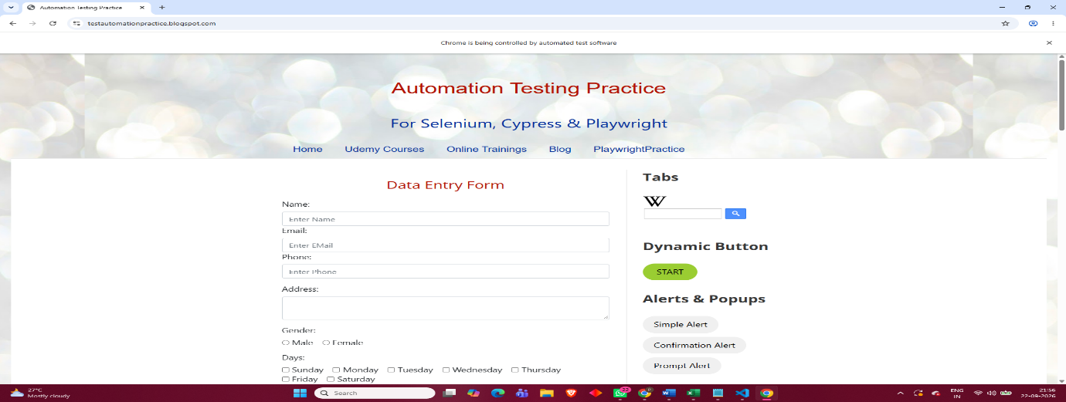

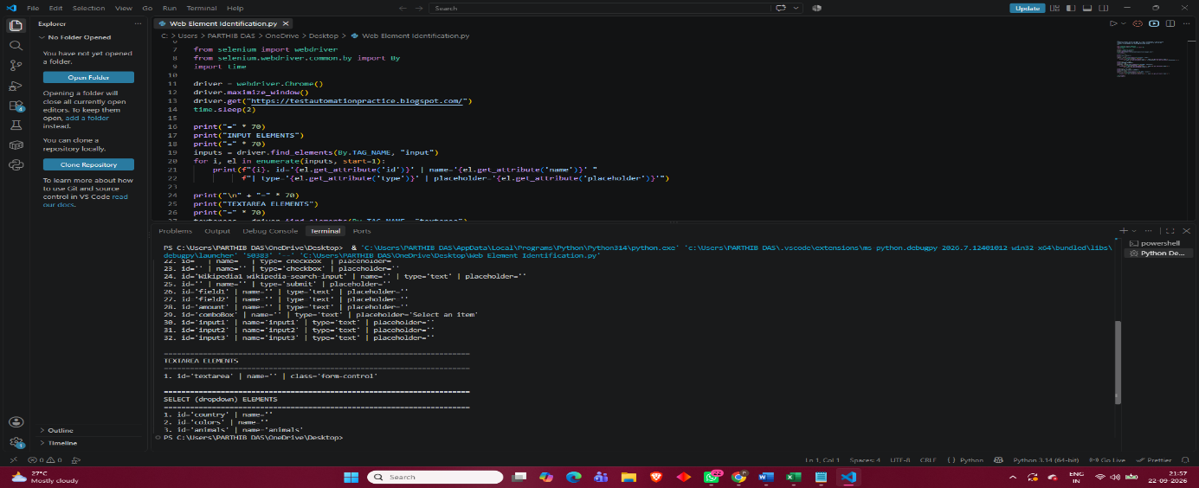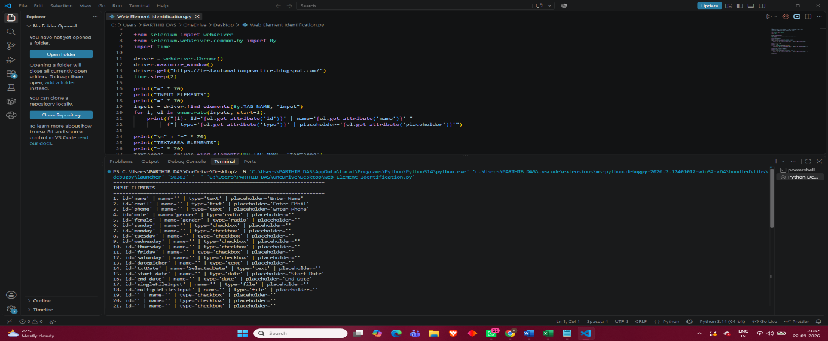
Result: Web elements were successfully identified using different Selenium locator strategies.
Observation: Selenium provides multiple locators such as ID, Name, Class Name, Tag Name, Link Text, CSS Selector, and XPath for locating elements.
Conclusion: The experiment helped understand the identification and basic interaction with web elements using Selenium WebDriver.

Experiment Title : Multiple Element Identification

Problem Statement:
To identify and locate multiple web elements on a webpage using Selenium WebDriver and suitable locator strategies, and to retrieve and interact with a collection of similar elements efficiently during web automation testing.

Objective
To learn how to identify multiple web elements using Selenium's find_elements() method with locators such as ID, Name, Class Name, Tag Name, CSS Selector, and XPath.

Tools, Software, and Concepts Used
- Python 3.x
- Selenium (latest version)
- Google Chrome / Mozilla Firefox
- Selenium WebDriver
- VS Code / PyCharm
- Required Python packages:
  - selenium
  - webdriver-manager
- Concepts: Multiple Web Elements, find_elements(), Locators, CSS Selectors, XPath

Source Code / Implementation Steps
- Install the required Python packages using pip.
- Import Selenium and the required WebDriver modules.
- Open the required webpage using Selenium WebDriver.
- Use the find_elements() method to locate multiple elements.
- Store the identified elements in a list.
- Iterate through the list to access or perform actions on each element.
- Verify the identified elements and close the browser using driver.quit().
Source Code:

from selenium import webdriver

from selenium.webdriver.common.by import By

from selenium.webdriver.support.ui import WebDriverWait

from selenium.webdriver.support import expected_conditions as EC

import time

driver = webdriver.Chrome()

driver.maximize_window()

driver.get("https://testautomationpractice.blogspot.com/")

wait = WebDriverWait(driver, 10)

# 1) Find all <a> (link) elements on the page and print their text + href

links = driver.find_elements(By.TAG_NAME, "a")

print(f"Total links found: {len(links)}\n")

for index, link in enumerate(links, start=1):

text = link.text.strip()

href = link.get_attribute("href")

if text: # skip empty/icon-only links

print(f"{index}. Text: '{text}' -> URL: {href}")

# 2) Find all <input> elements and print their 'type' attribute

print("\n--- Input field types on the page ---")

inputs = driver.find_elements(By.TAG_NAME, "input")

print(f"Total input elements found: {len(inputs)}")

for i, inp in enumerate(inputs, start=1):

print(f"{i}. type = {inp.get_attribute('type')}, id = {inp.get_attribute('id')}")

# 3) Find all checkboxes (elements of the same "type") and tick each one

checkboxes = driver.find_elements(By.CSS_SELECTOR, "input[type='checkbox']")

print(f"\nTotal checkboxes found: {len(checkboxes)}")

for cb in checkboxes:

if cb.is_displayed() and not cb.is_selected():

driver.execute_script("arguments[0].scrollIntoView(true);", cb)

cb.click()

print("All visible checkboxes have been checked.")

time.sleep(2)

driver.quit()
Output with clearly labelled screenshots:

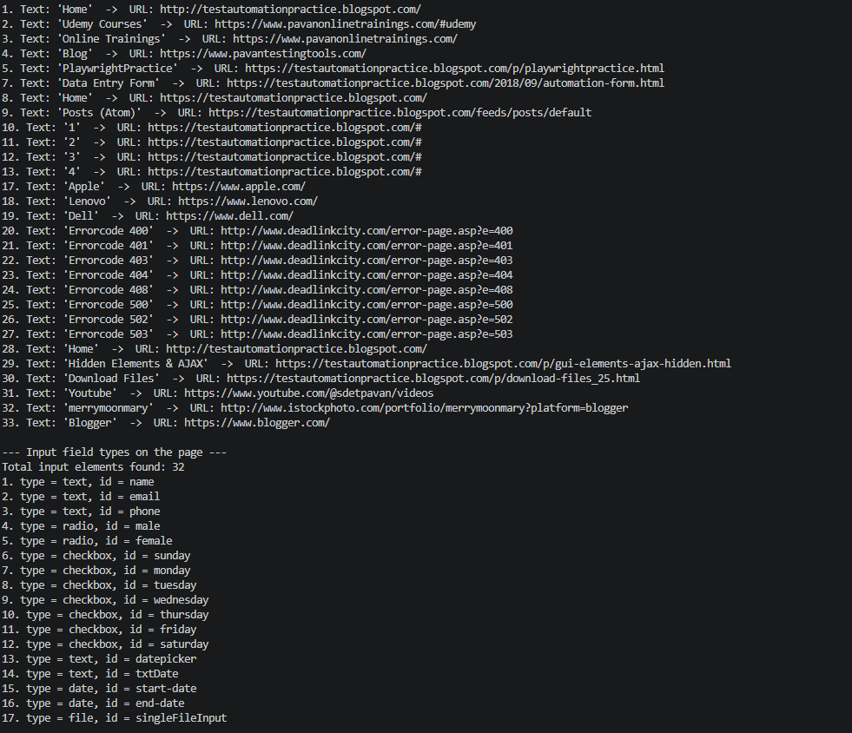

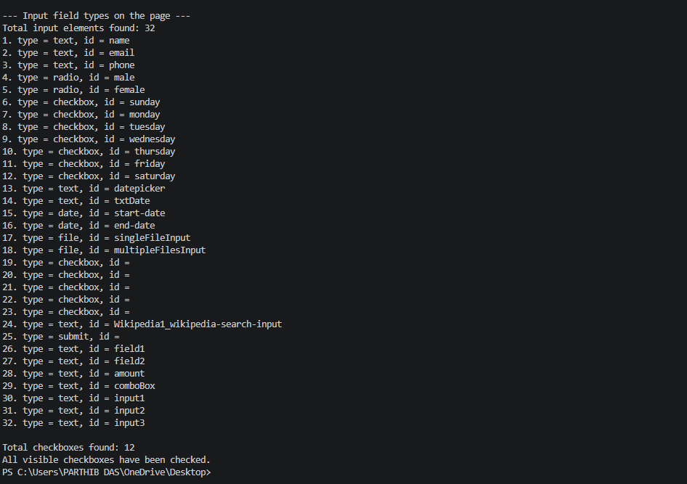

Result, Observation, and Conclusion
Result: Multiple web elements were successfully identified and accessed using Selenium WebDriver.
Observation: The find_elements() method returns a list of all matching web elements, allowing multiple similar elements to be processed together.
Conclusion: The experiment helped understand how to locate and work with multiple web elements efficiently using Selenium.

Experiment Title : Child Nodes Using CSS

Problem Statement
To identify and locate child elements within a parent web element using CSS Selectors in Selenium WebDriver and understand how CSS child selectors can be used for precise web element identification.

Objective
To learn how to locate child nodes/elements using CSS selectors such as parent > child and perform basic interactions with them using Selenium.

Tools, Software, and Concepts Used
- Python 3.x
- Selenium (latest version)
- Google Chrome / Mozilla Firefox
- Selenium WebDriver
- VS Code / PyCharm
- Required Python packages:
  - selenium
  - webdriver-manager
- Concepts: Child Nodes, Parent-Child Relationship, CSS Selectors, find_element(), find_elements()

Source Code / Implementation Steps
- Install the required Python packages using pip.
- Import Selenium and the required WebDriver modules.
- Open the required webpage using Selenium WebDriver.
- Identify the parent element using a suitable CSS selector.
- Use the > CSS child combinator to locate its direct child element.
- Perform an action such as clicking or retrieving the child element.
- Verify the result and close the browser using driver.quit().
Source Code:
from selenium import webdriver
from selenium.webdriver.common.by import By
import time
driver = webdriver.Chrome()
driver.maximize_window()
driver.get("https://testautomationpractice.blogspot.com/")
time.sleep(2)
def describe(label, by, value):
try:
el = driver.find_element(by, value)
print(f"{label}: FOUND")
print(f" tag='{el.tag_name}' id='{el.get_attribute('id')}' "
f"class='{el.get_attribute('class')}'")
# also show the parent, useful for building child selectors
parent = el.find_element(By.XPATH, "..")
print(f" PARENT -> tag='{parent.tag_name}' id='{parent.get_attribute('id')}' "
f"class='{parent.get_attribute('class')}'")
except Exception as e:
print(f"{label}: NOT FOUND ({e.__class__.__name__})")
print("-" * 70)
# "Point Me" hover button
describe("Point Me button", By.XPATH, "//*[contains(text(),'Point Me')]")
# "Mobiles" / "Laptops" dropdown links
describe("Mobiles link", By.LINK_TEXT, "Mobiles")
describe("Laptops link", By.LINK_TEXT, "Laptops")
# "Copy Text" button
describe("Copy Text button", By.XPATH, "//*[contains(text(),'Copy Text')]")
# Static web table
describe("Static table", By.XPATH,
"//table[.//td[contains(text(),'Learn Selenium')]]")
time.sleep(3)
driver.quit()
Output with clearly labelled screenshots:
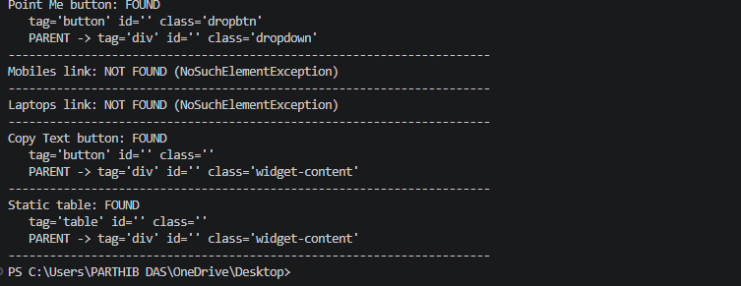
Result: Child elements were successfully identified using CSS child selectors.
Observation: The > CSS selector helps locate direct child elements of a specified parent element.
Conclusion: The experiment helped understand how CSS child selectors can be used for accurate and efficient web element identification in Selenium.

Experiment Title : Child Nodes Using CSS

Problem Statement
To identify and locate child nodes of a parent web element using CSS selectors in Selenium WebDriver for accurate web element identification and interaction.

Objective
To understand and implement CSS child selectors for locating direct child elements of a parent element using Selenium.

Tools, Software, and Concepts Used
- Python 3.x
- Selenium (latest version)
- Google Chrome / Mozilla Firefox
- Selenium WebDriver
- VS Code / PyCharm
- Python packages:
  - selenium
  - webdriver-manager
- Concepts: CSS Selectors, Child Nodes, Parent-Child Relationship, find_element(), find_elements()

Source Code / Implementation Steps
- Install Selenium and WebDriver Manager.
- Import the required Selenium modules.
- Launch the browser using Selenium WebDriver.
- Open the required webpage.
- Identify the parent element using a CSS selector.
- Use the > child selector to locate its direct child node.
- Perform the required action on the identified child element.
- Verify the output and close the browser.
Source Code :
from selenium import webdriver
from selenium.webdriver.common.by import By
from selenium.webdriver.support.ui import WebDriverWait
from selenium.webdriver.support import expected_conditions as EC
import time
driver = webdriver.Chrome()
driver.maximize_window()
driver.get("https://testautomationpractice.blogspot.com/")
wait = WebDriverWait(driver, 10)
name_field = wait.until(EC.presence_of_element_located((By.CSS_SELECTOR, "input#name")))
name_field.send_keys("Selenium Tester")
print("CSS id selector -> Name field filled")
date_fields = driver.find_elements(By.CSS_SELECTOR, "input[id^='date']")
print(f"Elements whose id starts with 'date': {len(date_fields)}")
for d in date_fields:
print(" ->", d.get_attribute("id"))
btn_elements = driver.find_elements(By.CSS_SELECTOR, "[id$='btn']")
print(f"\nElements whose id ends with 'btn': {len(btn_elements)}")
for b in btn_elements:
print(" ->", b.get_attribute("id"), "| text:", b.text)
table_elements = driver.find_elements(By.CSS_SELECTOR, "[id*='table' i]")
print(f"\nElements whose id contains 'table': {len(table_elements)}")
for t in table_elements:
print(" ->", t.get_attribute("id"))
day_checkboxes = driver.find_elements(By.CSS_SELECTOR, "input[type='checkbox'][id]")
print(f"\nCheckboxes that have a non-empty id attribute: {len(day_checkboxes)}")
for c in day_checkboxes:
print(" ->", c.get_attribute("id"))
time.sleep(2)
driver.quit()
Output with clearly labelled screenshots:
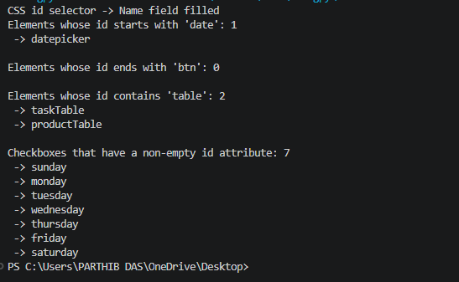
Result: The child nodes were successfully identified using CSS selectors.
Observation: The > CSS selector is used to locate the direct child of a specified parent element.
Conclusion: The experiment demonstrated how CSS child selectors can be effectively used for precise web element identification in Selenium.

